

THE STATE UNIVERSITY OF ZANZIBAR
SCHOOL COMPUTING, COMMUNICATION AND MEDIA STUDIES
DEPARTMENT OF COMPUTER SCIENCE AND INFORMATION
TECHNOLOGY

ZANHOTEL-AJIRA PORTAL SOFTWARE DESIGN DOCUMENT (SDD)

Name | Reg No
GIDION MKASANGA GIDION | BITAM/9/21/002/TZ

2025/2026

Contents
ZANHOTEL-AJIRA PORTAL SOFTWARE DESIGN DOCUMENT (SDD) i
SOFTWARE DESIGN DOCUMENT (SDD) 3
ZanHotel Ajira Portal System 3
1. INTRODUCTION 3
1.1 Purpose and Scope 3
Purpose 3
Scope 3
The system design covers the following areas: 4
1.1.1 System Architecture Design 4
1.1.2Database Design 4
1.1.3 Object-Oriented Design (OOD) 4
1.1.4 Component Interaction Design 5
1.1.5 Deployment Architecture 5
1.1.6 Internal System Behavior 5
1.1.7 Security Design 5
1.1.8 Performance Optimization Design 6
1.1.9 Scalability Design 6
1.2 Project Executive Summary 6
1.2.1Core System Capabilities 6
1.2.2 Job Posting Management 7
1.2.3 Job Application Processing 7
1.2.4. Document Management 7
1.2.5 Complaint Management System 7
System Architecture Overview 8
Frontend Layer (React) 8
Backend Layer (Django REST Framework) 8
Database Layer (PostgreSQL) 8
Key System Qualities 8
1.2.1 System Overview 9
High-Level Architecture 9
1. Client Layer (Presentation Layer) 9
2. API Layer (Application Layer) 9
3. Data Layer (Database Layer) 10
External System Interactions 10
1. Web Browsers 10
2. Cloud Hosting Services 11
3. Email Notification Services (Optional Enhancement) 11
4. File Storage Services (Optional Enhancement) 11
System Interaction Flow (Conceptual) 11
1.2.2 Design Constraints 12
1.2.3 Technology Stack Constraint (Django + React) 12
Implications: 12
Reason: 12
1.2.4 Online-Only System Constraint 12
Implications: 13
Technical Impact: 13
Reason: 13
1.2.5 REST API Architecture Constraint 13
Requirements: 13
Implications: 13
Reason: 14
4. Secure Authentication Constraint (JWT) 14
Requirements: 14
Implications: 14
Security Benefits: 14
6. File Upload Constraint 14
7. Security Constraint 15
8. Performance Constraint 15
1.2.3 Future Enhancements 15
1. Payment Gateway Integration 15
Description: 15
Possible Features: 15
Possible Integrations: 15
Benefits: 16
2. AI-Based Job Recommendation System 16
Description: 16
Functionality: 16
Technologies: 16
Benefits: 16
3. Mobile Application Version 16
Description: 16
Features: 16
Technologies: 17
Benefits: 17
4. Real-Time Notification System 17
5. Advanced Admin Dashboard 17
6. Resume Parsing System 17
7. Chat System Between Hotel and Applicants 17
Summary 17
Design Constraints: 17
1.2.3Future Enhancements: 18
1.3 Document Organization 18
1.4 References 18
2. SYSTEM ARCHITECTURE 18
2.1 System Hardware Architecture 18
2.2 System Software Architecture 18
2.3 Internal Communication Architecture 19
3. SEQUENCE DIAGRAMS 19
3.1 Job Application Sequence 19
Flow: 19
Job Application Sequence: 19
3.2 Job Posting Sequence 21
Flow: 21
4.1 System Components 22
Components: 22
Communication: 22
5. DEPLOYMENT DIAGRAM 22
5.1 System Deployment Architecture 22
Nodes: 22
Deployment Flow: 23
6. INTERNAL DESIGN SUMMARY 23
7. CONCLUSION 23

SOFTWARE DESIGN DOCUMENT (SDD)

ZanHotel Ajira Portal System

1. INTRODUCTION

1.1 Purpose and Scope

Purpose
This document provides a comprehensive and technical description of the system design of the ZanHotel Ajira Portal, a web-based recruitment platform developed to connect hotels (employers) with job seekers in a centralized digital environment.
This document is translating the Software Requirements Specification (SRS) into a detailed architectural blueprint that guides system implementation, integration, testing, and deployment.

Scope
The scope of this design document covers the full internal structure and technical behavior of the system, including both backend and frontend components.

The system design covers the following areas:

1.1.1 System Architecture Design
Defines how the system is structured into layers and how components interact:
- Presentation layer (React frontend)
- Application layer (Django REST API)
- Data layer (PostgreSQL database)
It also describes communication protocols such as HTTP/HTTPS and JSON-based data exchange.

1.1.2Database Design
Defines how data is structured, stored, and retrieved:
- Entity relationships (ERD)
- Table structures
- Primary and foreign keys
- Data normalization principles
- Data integrity constraints
This ensures efficient storage and retrieval of system data such as users, jobs, and applications.

1.1.3 Object-Oriented Design (OOD)
Defines the internal software structure using classes and objects:
- Class definitions (User, Job, Application, etc.)
- Relationships (inheritance, association, aggregation)
- Encapsulation of business logic
- Reusable software components
This ensures modularity and maintainability of the system.

1.1.4 Component Interaction Design
Describes how different system modules communicate:
- Authentication module
- Job management module
- Application processing module
- Notification module
This ensures smooth integration between system features.

1.1.5 Deployment Architecture
Defines how the system is deployed in a real environment:
- Web server setup (Nginx/Apache)
- Application server (Django)
- Database server (PostgreSQL)
- Cloud hosting (AWS/DigitalOcean)
This ensures system availability and scalability.

1.1.6 Internal System Behavior
Defines how the system behaves during execution:
- Request-response flow
- Data validation logic
- Error handling mechanisms
- Security enforcement (JWT, RBAC)

1.1.7 Security Design
- Authentication and authorization mechanisms
- Role-based access control (Admin, Hotel, Job Seeker)
- Protection against SQL Injection, XSS, CSRF
- Secure file upload handling

1.1.8 Performance Optimization Design
- Caching strategies
- Database indexing
- Load handling for concurrent users
- API optimization

1.1.9 Scalability Design
- Horizontal scaling (adding servers)
- Cloud deployment readiness
- Stateless backend design

1.2 Project Executive Summary
The ZanHotel Ajira Portal is a digital recruitment management system designed to modernize and automate the hiring process within the hotel industry. The platform eliminates traditional manual recruitment processes (such as physical CV submission and manual shortlisting) by providing a centralized, online system for job posting, application submission, and candidate management.
The system supports three primary user categories:
- Job Seekers: individuals searching for employment opportunities
- Hotels (Employers): organizations posting job vacancies
- Administrators: system controllers managing platform integrity

1.2.1Core System Capabilities
The system provides the following key functionalities:

1.2.2 Job Posting Management
Hotels can:
- Create job advertisements
- Define job requirements
- Set application deadlines
- Edit or remove job postings

1.2.3 Job Application Processing
Job seekers can:
- Browse available jobs
- Apply for jobs online
- Upload supporting documents (CV, certificates, photos)
- Track application status

1.2.4. Document Management
The system supports secure uploading and storage of:
- Curriculum Vitae (CV)
- Academic certificates
- Identification photos

1.2.5 Complaint Management System
Users can:
- Submit complaints or reports
- Track complaint status
- Receive responses from administrators

System Architecture Overview
The system follows a modern three-tier architecture, which separates responsibilities into independent layers:

Frontend Layer (React)
- Provides user interface
- Handles user interactions
- Communicates with backend via REST APIs

Backend Layer (Django REST Framework)
- Handles business logic
- Processes requests
- Enforces security rules
- Manages authentication and authorization

Database Layer (PostgreSQL)
- Stores all persistent system data
- Ensures data integrity and consistency
- Supports relational data modeling

Key System Qualities
The system is designed to ensure:
- Efficiency: Fast response time for user actions
- Security: Protection of sensitive user data
- Scalability: Ability to handle growing users and job postings
- Reliability: Continuous availability with minimal downtime
- Maintainability: Modular and well-structured codebase

1.2.1 System Overview
The ZanHotel Ajira Portal is designed as a distributed web-based system that operates over the internet using a client-server architecture. The system separates user interaction, processing logic, and data storage into distinct layers to ensure modularity, scalability, and maintainability.

High-Level Architecture

1. Client Layer (Presentation Layer)
This layer represents the user interface built using React.js.

Responsibilities:
- Display system interface to users
- Capture user inputs (login, registration, job application)
- Render job listings and dashboards
- Send requests to backend APIs

Key Features:
- Responsive UI design
- Dynamic rendering of content
- Form validation (client-side)

2. API Layer (Application Layer)
This layer is implemented using Django REST Framework (DRF).

Responsibilities:
- Process incoming HTTP requests
- Execute business logic
- Authenticate users using JWT
- Enforce system rules (business logic)
- Return structured JSON responses

Key Features:
- RESTful API design
- Secure authentication and authorization
- Role-based access control (RBAC)
- Data validation and sanitization

3. Data Layer (Database Layer)
This layer uses PostgreSQL as the primary database system.

Responsibilities:
- Store structured relational data
- Maintain data integrity
- Handle relationships between entities
- Support efficient querying

Key Data Entities:
- Users
- Jobs
- Applications
- Documents
- Complaints

External System Interactions
The system interacts with external services to enhance functionality:

1. Web Browsers
Users access the system via modern browsers such as:
- Google Chrome
- Mozilla Firefox
- Microsoft Edge

2. Cloud Hosting Services
The system can be deployed on cloud platforms such as:
- AWS (Amazon Web Services)
- DigitalOcean
- Heroku (optional)
These services provide:
- High availability
- Scalability
- Remote accessibility

3. Email Notification Services (Optional Enhancement)
The system may integrate email services for:
- Account verification
- Job application notifications
- Password recovery
- System alerts
Examples:
- SMTP servers
- SendGrid API
- AWS SES (Simple Email Service)

4. File Storage Services (Optional Enhancement)
For handling uploaded documents:
- AWS S3
- Google Cloud Storage
- Local server storage (basic implementation)

System Interaction Flow (Conceptual)
- User interacts with React frontend
- Frontend sends HTTP request to Django API
- Django processes request and applies business logic
- PostgreSQL stores or retrieves data
- Response is sent back to frontend
- UI updates dynamically based on response

1.2.2 Design Constraints
Design constraints refer to the limitations, rules, and mandatory conditions that restrict how the system can be designed and implemented. These constraints ensure consistency with project requirements, technology choices, and security standards.

1.2.3 Technology Stack Constraint (Django + React)
The system must strictly use:
- Django / Django REST Framework (Backend)
- React.js (Frontend)

Implications:
- Backend logic must be implemented using Python and Django ORM.
- API communication must be handled using Django REST Framework.
- Frontend must follow React component-based architecture.
- No alternative backend frameworks (e.g., Laravel, Spring Boot) are allowed.

Reason:
This constraint ensures:
- Consistency in development environment
- Easier maintenance and debugging
- Alignment with academic project requirements
- Separation of concerns between frontend and backend

1.2.4 Online-Only System Constraint
The system must operate exclusively in an online environment, meaning it requires an active internet connection for full functionality.

Implications:
- No offline data storage or offline job browsing
- All requests must be processed through server communication
- Users must authenticate through online APIs

Technical Impact:
- Requires reliable hosting infrastructure (cloud or VPS)
- System availability depends on server uptime
- Network latency may affect performance

Reason:
- Ensures centralized data consistency
- Enables real-time updates for jobs and applications
- Supports multi-user access across different locations

1.2.5 REST API Architecture Constraint
The system must follow a RESTful API design architecture for all backend communication.

Requirements:
- Use HTTP methods:
  - GET (retrieve data)
  - POST (create data)
  - PUT/PATCH (update data)
  - DELETE (remove data)
- Data exchange must use JSON format
- Stateless communication between client and server

Implications:
- Backend must be designed as an API service layer
- Frontend communicates only via API endpoints
- No direct database access from frontend

Reason:
- Ensures scalability and modularity
- Enables separation of frontend and backend
- Supports future mobile application integration

4. Secure Authentication Constraint (JWT)
The system must implement JWT (JSON Web Token) for authentication and authorization.

Requirements:
- Users must log in to receive a token
- Token must be included in all protected API requests
- Token expiration must be enforced
- Role-based access control must be applied

Implications:
- Secure session handling without server-side session storage
- Stateless authentication system
- Token validation required for every protected route

Security Benefits:
- Prevents unauthorized access
- Reduces risk of session hijacking
- Supports scalable distributed systems
5. Database Constraint
- Must use PostgreSQL only
- Must follow relational database design principles
- Must enforce foreign key relationships and normalization

6. File Upload Constraint
- Only allowed file types:
  - PDF (CVs)
  - PDF (Certificates)
  - Images (JPG, PNG for profile photos)
- Maximum file size limit must be enforced
- Files must be validated before storage

7. Security Constraint
- Must implement protection against:
  - SQL Injection
  - Cross-Site Scripting (XSS)
  - Cross-Site Request Forgery (CSRF)
- All communication must use HTTPS

8. Performance Constraint
- API response time should remain under 3 seconds under normal load
- System must support concurrent users without failure

1.2.3 Future Enhancements
Future enhancements describe planned improvements and system evolution opportunities that are not part of the current implementation but may be added in later versions.
These enhancements aim to improve functionality, scalability, and user experience.

1. Payment Gateway Integration

Description:
The system may integrate online payment services to support paid job postings or premium employer services.

Possible Features:
- Job posting fees for hotels
- Premium job listings (featured ads)
- Subscription plans for employers

Possible Integrations:
- Stripe API
- PayPal API
- Mobile Money APIs (e.g., M-Pesa, Tigo Pesa)

Benefits:
- Revenue generation
- Platform sustainability
- Enhanced business model

2. AI-Based Job Recommendation System

Description:
A machine learning module can be added to recommend jobs to users based on their profile, skills, and behavior.

Functionality:
- Analyze user applications
- Match skills with job descriptions
- Suggest relevant job opportunities

Technologies:
- Python ML libraries (Scikit-learn, TensorFlow)
- Recommendation algorithms (collaborative filtering, content-based filtering)

Benefits:
- Improves user experience
- Increases job application success rate
- Makes platform more intelligent and personalized

3. Mobile Application Version

Description:
A mobile version of the system can be developed for Android and iOS platforms.

Features:
- Job browsing on mobile devices
- Push notifications for new jobs
- Instant application submission
- Real-time status updates

Technologies:
- React Native
- REST API integration with existing backend

Benefits:
- Increased accessibility
- Wider user reach
- Better user engagement

4. Real-Time Notification System
- Email notifications
- SMS alerts
- In-app notifications

5. Advanced Admin Dashboard
- Analytics dashboard
- Job application statistics
- User activity monitoring

6. Resume Parsing System
- Automatically extract user’s data
- Match qualifications with job requirements

7. Chat System Between Hotel and Applicants
- Direct communication feature
- Interview scheduling support

Summary

Design Constraints:
- Define mandatory technical and architectural rules
- Ensure system consistency, security, and performance
- Limit technology stack and enforce standards

1.2.3Future Enhancements:
- Extend system functionality beyond core requirements
- Improve intelligence, scalability, and usability
- Enable monetization and mobile expansion

1.3 Document Organization
This document includes:
- Architecture design
- Database design
- UML diagrams
- System deployment design

1.4 References
- IEEE SRS/SDD Standards
- Django Documentation
- React Documentation
- PostgreSQL Documentation

2. SYSTEM ARCHITECTURE

2.1 System Hardware Architecture
- User Devices (Mobile, PC)
- Web Server (Nginx/Apache)
- Application Server (Django)
- Database Server (PostgreSQL)
- Cloud Hosting (AWS/DigitalOcean)

2.2 System Software Architecture
- Frontend: React.js
- Backend: Django REST Framework
- Database: PostgreSQL
- Authentication: JWT
- File Storage: Local/Cloud (AWS S3 optional)

2.3 Internal Communication Architecture
- REST API (HTTP/HTTPS)
- JSON data exchange

3. SEQUENCE DIAGRAMS

3.1 Job Application Sequence

Flow:
- User logs in
- System validates credentials
- User selects Job
- Upload CV/Document
- Submit Application
- System stores data
- Hotel receives notification

Job Application Sequence:
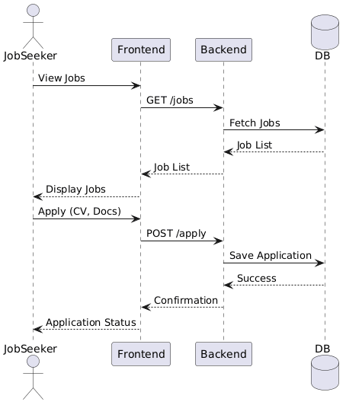

3.2 Job Posting Sequence

Flow:
- Hotel logs in
- Creates job post
- System validates input
- Saves job in database
- Job appears in listings
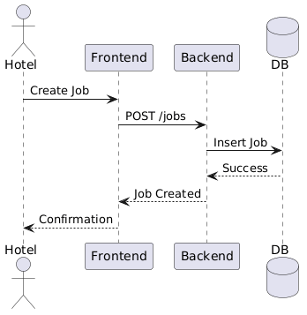

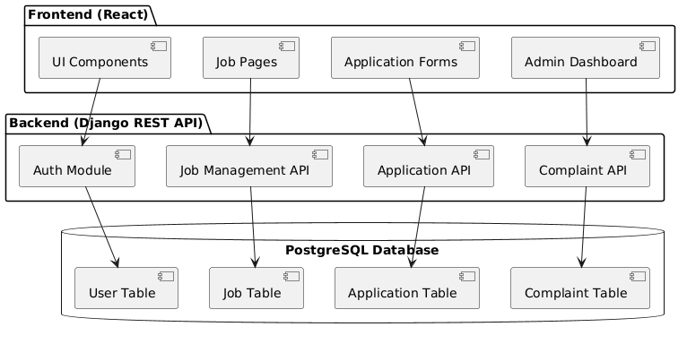
4.1 System Components

Components:
- React Frontend
- Django API Server
- Authentication Module
- Job Management Module
- Application Module
- Database Layer (PostgreSQL)

Communication:
- Frontend ↔ API via REST
- API ↔ DB via ORM

5. DEPLOYMENT DIAGRAM

5.1 System Deployment Architecture

Nodes:
- Client Device (Browser)
- Web Server (Nginx)
- Application Server (Django)
- Database Server (PostgreSQL)
- Cloud Platform (AWS / DigitalOcean)

Deployment Flow:
Client → Web Server → App Server → Database

6. INTERNAL DESIGN SUMMARY
Component | Technology
Frontend | React
Backend | Django REST
Database | PostgreSQL
Auth | JWT
Hosting | AWS/DigitalOcean

7. CONCLUSION
This SDD provides a complete technical blueprint of the ZanHotel Ajira Portal, covering architecture, database structure, object design, system behavior, and deployment strategy. It ensures developers can implement the system accurately and consistently.

